End-to-End Data Analytics Project Documentation

## Step 1: Importing the Data

The dataset was provided in CSV format. I imported `data_for_part_3.csv` into MySQL Workbench using the table name `raw_orders`.

## Step 2: Data Normalization

To ensure a clean and analytical structure, I normalized the raw data into dimension and fact tables. I created a stored procedure named `NormalizeOrders2()` that broke the data into:

- Dim_Customers  
- Dim_Products  
- Dim_Targets_Orders  
- Dim_Date  
- Fact_Order_Lines  
- Fact_Orders_Aggregate

Each dimension contains unique values with relevant metadata. The fact tables include transactional data required for KPI calculations.

Screen shot of SQL QUERY CODE:

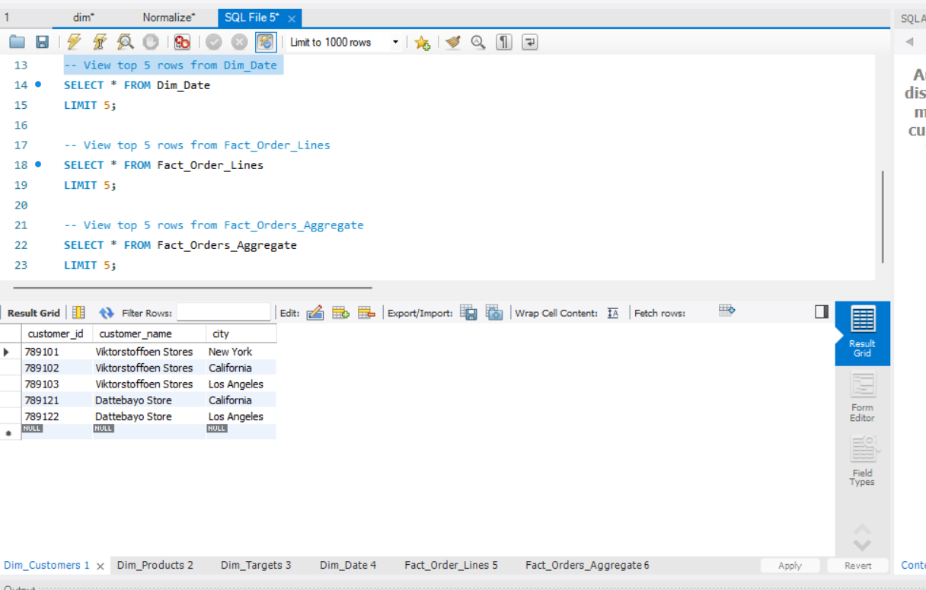

**For Better understanding SQL CODE Attach Another file**

## Step 3: Connecting SQL to Power BI

Using Power BI, I connected directly to the MySQL database. After successfully loading all dimension and fact tables, I created relationships among them to establish a star schema suitable for analysis.

## Step 4: KPI Measures Created

Below are the KPIs calculated using DAX:

- Total Order Lines: Count of all order lines.

- Line Fill Rate (LIFR %): Shipped in full quantity lines / total lines.

- Volume Fill Rate (VOFR %): Shipped quantity / ordered quantity.

- On Time Delivery (OT %): Orders delivered on or before agreed date.

- In Full Delivery (IF %): Orders where all items were shipped in full.

- On Time In Full (OTIF %): Orders both on-time and in-full.

- On Time Target: Average from target table.

- In Full Target: Average from target table.

- OTIF Target: Average from target table.

## Step 5: KPI Visuals

Cards:  
- Total Orders  
- On-Time Orders  
- In-Full Orders  
- OTIF Orders

Bar Chart:  
- % of Total Orders by Customer

Gauge Charts:  
- OT %, IF %, OTIF % compared with their respective targets.

## Step 6: Dynamic Line Chart for KPIs

Created a field parameter table to switch between:  
- On-Time  
- In-Full  
- OTIF  
- LIFR  
- VOFR  
Chart title and Y-axis update based on selection.

## Step 7: Delay Calculation & Categorization

To calculate delay:

DelayDays =  
DATEDIFF(  
 SELECTEDVALUE(Fact_Order_Lines[agreed_delivery_date]),  
 SELECTEDVALUE(Fact_Order_Lines[actual_delivery_date]),  
 DAY  
)

Categorization:

DelayCategory =  
SWITCH(  
 TRUE(),  
 [DelayDays] <= 0, "Delivered On Time",  
 [DelayDays] = 1, "1 Day Late",  
 [DelayDays] = 2, "2 Days Late",  
 [DelayDays] = 3, "3 Days Late",  
 [DelayDays] > 3, "More than 3 Days Late",  
 "Unknown"  
)

A disconnected table was created manually with 5 categories for slicer functionality.

## Step 8: Delay-Based Visuals

Matrix Table: Delay Category vs. Product Category.  
Bar Chart: % Orders by Delay Category & City.  
Slicer: Uses the disconnected delay category table to filter visuals.

## Step 9: Report Interpretation Page

Insights:  
- High % of late deliveries concentrated in a few cities.  
- Certain product categories face consistent delays.  
- In-Full delivery is generally higher than On-Time, impacting OTIF.

Recommendations:  
- Improve delivery scheduling.  
- Investigate vendor lead time issues.  
- Align expectations with performance by region and product.